 | LUN | MAR | MER | GIO | VEN | SAB
09.00 | Ginn. Dolce | B.A.G. | Ginn. Dolce | Aero-Tone | Ginn. Dolce | Power-Tone
10.00 | Pump |  | H.I.I.T. |  | Pump
11.00 | Zumba |  | Zumba |  | Zumba
13.30 | Dynamic Tone |  | Interval training |  | G.A.G.
16.30 | Prepugilistica |  | Prepugilistica |  | Prepugilistica
17.00 |  | Power-Tone |  | Aero-Tone
18.00 | H.I.I.T. |  | Pump |  | H.I.I.T.
18.00 |  | Life pump |  | Life pump
19.00 | Pump |  | Total Body |  | Pump
19.15 |  | Prepugilistica |  | Prepugilistica
20.00 | Dynamic Tone |  | Dynamic Tone |  | H.I.I.T.  (CIRCUITO)
20.30 |  | Prepugilistica |  | Prepugilistica
Sala 2 SPINNING
Sala 1 FITNESS
 | LUN | MAR | MER | GIO | VEN | SAB
08.00 | Spinning |  | Spinning |  | Spinning
09.00 |  |  |  |  |  | Spinning
17.00 |  | Spinning |  | Spinning
17.30 | Spinning |  | Spinning |  | Spinning
18.30 |  | Spinning |  | Spinning
19.00 | Spinning |  | *Cyclex |  | Spinning
Orario Assistenza sala Body Building
Lun - Ven: 09.00 - 13.00 17.00 - 21.00

Orario sala Body Building
Lun - Ven: 07.00 / 22.00
Sabato: 07.00 / 18.30
Domenica 09.00 / 12.30

Prenotazioni obbligatorie
tramite l’App Sportclubby per
Sala 1 – Sala 2 – Sala 3

Cyclex e’ un nuovo format che abbina alla pedalata un lavoro di Total Body Work Out sulla bike.
L’obbiettivo e’ proporre un’idea di Fitness, che si affianca all’ormai classico indoor cycling coinvolgendo fasce d’utenza diverse e soprattutto le nuove generazioni.

 | LUN | MAR | MER | GIO | VEN | SAB
07.30 |  | Pancafit  posturale |  | Pancafit  posturale |  | Pancafit  posturale
08.30
09.00 |  | Pancafit  posturale |  | Pancafit  posturale |  | Pancafit  posturale
10.30
14.30 | Pancafit  posturale |  | Pancafit  posturale |  | Pancafit  posturale
17.30 | Anukalana Yoga |  | Anukalana Yoga |  | Anukalana  Yoga
18.00 |  | Pilates |  | Pilates
19.00 | Pancafit  posturale |  | Pancafit  posturale |  | Pancafit  posturale
20.00 | Pancafit  posturale |  | Pancafit  posturale |  | Pancafit  posturale
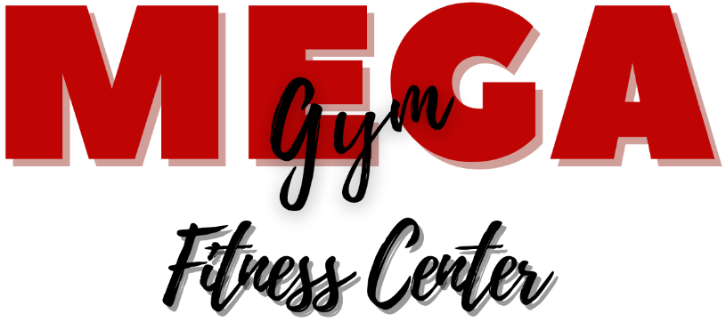

Sala 3 POSTURALE - PILATES - YOGA
Orari NOVEMBRE 2021
Posturale - Pancafit
Ginnastica Dolce
Prepugilistica
Zumba
H.I.I.T.
G.A.G.
Yoga
Pilates
Aero-Pilates
Spinning
Mega Gym S.r.l Via A. Zotti, 41/49 00121 Ostia
www.megagym.it info@megagym.it
06-5693788

Orario Palestra
Lun - Ven: 07.00 / 22.30
Sabato: 07.00 / 19.00
Domenica 09.00 / 13.00

Prenotazioni obbligatorie
tramite l’App Sportclubby per
Sala 1 – Sala 2 – Sala 3

